**PF Lab 10**

**Name: Ali Rooman**

**Roll No: 24K-0792**

1. Create a program with a constant that defines the maximum allowable temperature (in Celsius). Write a function to compare input temperatures and use a static variable to count how many times temperatures exceeded the limit.

|  |
| --- |
| #include <stdio.h>  #define MAXTEMP 30  void checktemperature(int temp) {  static int exceedcount = 0;  if (temp > MAXTEMP) {  exceedcount++;  printf("Temperature %d °C exceeds the limit of %d°C.\n", temp, MAXTEMP);  } else {  printf("Temperature %d °C is within the allowable range.\n", temp);  }  printf("Times temperature exceeded the limit: %d\n", exceedcount);  }  int main() {  int temp;  printf("Enter a temperature (Celsius): ");  while (scanf("%d", &temp) == 1) {  if (temp == 0){  break;  }  checktemperature(temp);  printf("Enter another temperature (Celsius), or 0 to exit: ");  }  printf("Exiting program..... ");  return 0;  } |

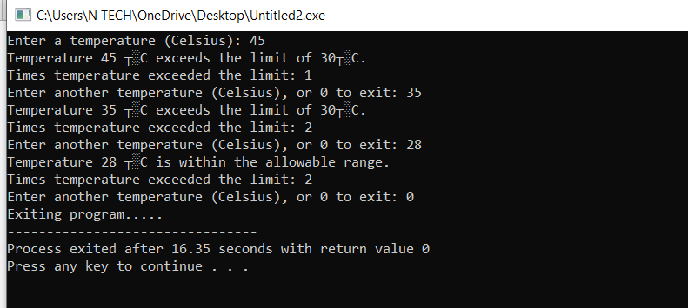**OUTPUT**

2. Create a C program that defines a constant for the conversion factor of meters to kilometers. Use a static variable in a function to count how many times the function is called.

|  |
| --- |
| #include <stdio.h>  #define METERS_TO_KM 0.001  void convertkilometers(double meters) {      static int call_count = 0;      printf("%.2f meters = %.2f kilometers\n", meters, meters * METERS_TO_KM);      printf("Function called %d times.\n", ++call_count);  }  int main() {      double meters;      while (1) {          printf("Enter meters (0 to exit): ");          scanf("%lf", &meters);          if (meters == 0) break;          convertkilometers(meters);      }      return 0;  } |

**OUTPUT**

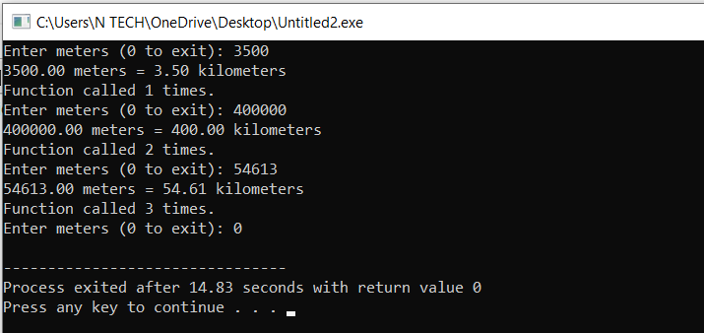

3. Write a recursive function to calculate (a raised to the power of b), where both a and b are non-negative integers.

|  |
| --- |
| #include <stdio.h>  int power(int a,int b){      if(b==0){          return 1;      }      else{          return a * power(a,b-1);      }  }  int main(){      int a,b;      printf("Enter base (a): ");      scanf("%d", &a);      printf("Enter exponent (b): ");      scanf("%d", &b);       while (a < 0 || b < 0) {          if (a < 0) {              printf("Enter +ve base: ");              scanf("%d", &a);          }          if (b < 0) {              printf("Enter +ve exponent: ");              scanf("%d", &b);          }      }      printf("%d raised to the power %d is: %d",a,b,power(a,b));      return 0;  } |

**OUTPUT**

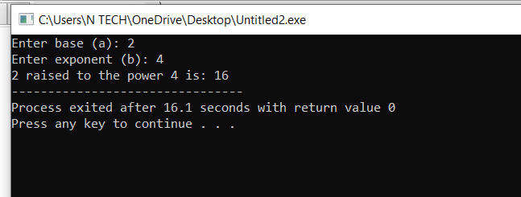

4. Write a recursive function that counts the occurrences of a specific digit in a given integer. For instance, if the input is 1221 and the target digit is 2, the output should be 2 because 2 appears twice.

|  |
| --- |
| #include <stdio.h>  #include <math.h>  int countdigit(int n, int targetdigit) {  if (n == 0) {  return 0;  }  if (n < 0) {  n = -n;  }  if (n % 10 == targetdigit) {  return 1 + countdigit(n / 10, targetdigit);  } else {  return countdigit(n / 10, targetdigit);  }  }  int main() {  int number;  int targetdigit;  printf("Enter a number: ");  scanf("%d", &number);  printf("Enter a target digit (0-9): ");  scanf("%d", &targetdigit);  if (targetdigit < 0 || targetdigit > 9) {  printf("Please enter a valid digit between 0 and 9.\n");  return 1;  }  int count = countdigit(abs(number), targetdigit);  printf("The digit %d appears %d times in %d.\n", targetdigit, count, number);  return 0;  } |

**OUTPUT**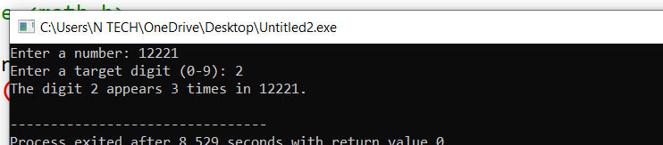

5. Design a structure to store information about a book, including the title, author, and the number of pages. Write a program that allows the user to input the details of a book and display the information.

|  |
| --- |
| #include <stdio.h>  #include <string.h>  struct book {  char tittle[100];  char author[50];  int pages;  };  void printBook(struct book b) {  printf("\n----- Book Details -----\n");  printf("Title: '%s'\n", b.tittle);  printf("Author: %s\n", b.author);  printf("Pages: %d\n", b.pages);  printf("\n------------------------\n");  }  int main() {  int n;  printf("Enter the number of books you want to insert data for: ");  scanf("%d", &n);  getchar();  struct book b[n];  int i;  for (i = 0; i < n; i++) {  printf("\nEnter the title of book %d: ", i + 1);  fgets(b[i].tittle, sizeof(b[i].tittle), stdin);  b[i].tittle[strcspn(b[i].tittle, "\n")] = '\0';  printf("Enter the author of book %d: ", i + 1);  fgets(b[i].author, sizeof(b[i].author), stdin);  b[i].author[strcspn(b[i].author, "\n")] = '\0';  printf("Enter the number of pages in book '%s': ", b[i].tittle);  scanf("%d", &b[i].pages);  getchar();  }  printf("\n\n----- Books Information -----\n");  for (i = 0; i < n; i++) {  printBook(b[i]);  }  return 0;  } |

**OUTPUT**

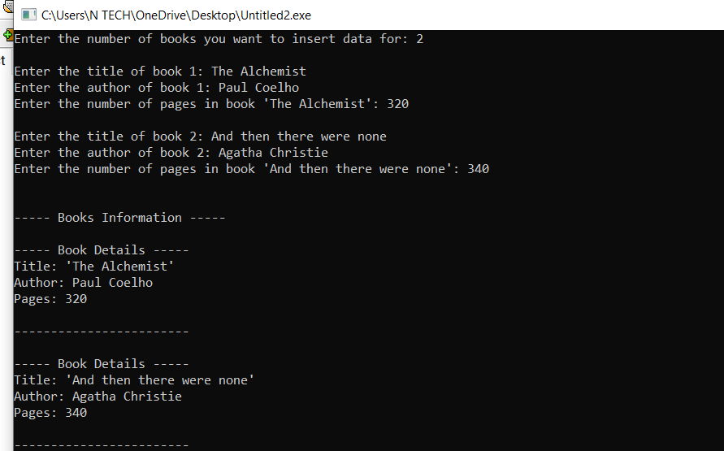

6. Design a structure to store information about students, including their name, age, roll number, and marks in three subjects. Write a program that allows the user to input the details of multiple students, display the information of all students, and calculate the average marks for each student.

|  |
| --- |
| #include <stdio.h>  #include <string.h>  struct Student {  char name[50];  int age;  int rollNumber;  float marks[3];  };  void displayDetails(struct Student s) {  printf("\nStudent Name: %s\n", s.name);  printf("Age: %d\n", s.age);  printf("Roll Number: %d\n", s.rollNumber);  printf("Marks: Subject 1 = %.2f, Subject 2 = %.2f, Subject 3 = %.2f\n", s.marks[0], s.marks[1], s.marks[2]);    float totalMarks = 0.0;  int i;  for (i = 0; i < 3; i++) {  totalMarks += s.marks[i];  }  float average = totalMarks / 3;  printf("Average Marks: %.2f\n", average);  }  int main() {  int n, i, j;  printf("Enter the number of students: ");  scanf("%d", &n);  getchar();  struct Student students[n];  for (i = 0; i < n; i++) {  printf("\nEnter details for student %d:\n", i + 1);  printf("Enter student's name: ");  fgets(students[i].name, sizeof(students[i].name), stdin);  students[i].name[strcspn(students[i].name, "\n")] = '\0';  printf("Enter student's age: ");  scanf("%d", &students[i].age);  printf("Enter student's roll number: ");  scanf("%d", &students[i].rollNumber);  printf("Enter marks for three subjects:\n");  for (j = 0; j < 3; j++) {  printf("Marks in subject %d: ", j + 1);  scanf("%f", &students[i].marks[j]);  }  getchar();  }  for (i = 0; i < n; i++) {  printf("\nDetails of student %d:\n", i + 1);  displayDetails(students[i]);  }  return 0;  } |

**OUTPUT**

